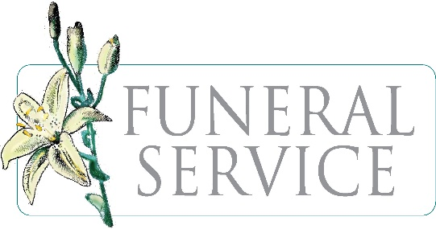
“The eternal God is thy refuge, and underneath are the everlasting arms.”
Deuteronomy 33:27 NIV

METROPOLITAN UNITED METHODIST CHURCH
Reverend Darryl K. Mason, Sr., Pastor
3385 Metropolitan Church Road Indian Head, MD 20640
Church Office: 301-375-9088 / 301-744-7742 Fax: 301-375-9009
Email: metroumc@verizon.net

Funeral Policies and Procedures

❖ Pastoral Services and Counseling
- The Pastor must be notified before any funeral arrangements are made to discuss and review our church’s service format. Appropriate arrangements will be made in consultation with the pastor, family, and mortician.
- Payment is made directly to the Pastor or designee and is due during the final consultation or on the day of the funeral. Pastoral counseling and assistance are available to families in selection of funeral directors and/or any other services that the family may need.

❖ Funeral Service
- Services may be held at Metropolitan UMC for active members, inactive members, and community members.
- The funeral service will be held in the sanctuary and the casket will be placed before the altar in front of the chancel rail. Persons who wish to view the deceased may do so upon entrance to the church. Before the service begins, the casket will be closed with no further viewing. (Exceptional circumstances will be left to the discretion of the Pastor.)
- Any lodge, organization, fraternity, or sorority that wishes to make their presentation will do so during the family hour or at the grave site following the committal services. Lodges and organizations that wish to have ceremonies must get clearance and time for presentation from the Pastor in advance.
- There will be no service in the Sanctuary after the Spoken Word. [The Book of Worship, pages 139-155].

❖ Funeral Programs
- Metropolitan UMC no longer provides funeral programs.
- While this is our policy, our Pastor still must review a draft of the program before the final printing. If possible, please email a copy of the program to: metroumc.ofc@gmail.com three (3) days before service.

❖ Repasts
- Metropolitan UMC no longer provides repast meals for families.
- Families may use our banquet hall a repast using a caterer only. We will provide the hall at no cost for active members only. Please call (301) 344-7742 to discuss usage of our facilities.

❖ PowerPoint Presentations and Videos
- Metropolitan UMC no longer provides PowerPoint slides.
- You may provide prepared PowerPoint presentations. Prepared presentations must not exceed thirty (30) slides in length and must be submitted to the church office three (3) days prior to the funeral for review. You can email files to: metroumc@verizon.net.
- Videos must be submitted to the church office three (3) days prior to the funeral for review.
- All videos must be in DVD or mp4 format and should not exceed five (5) minutes in length.

❖ Interment in the Church Cemetery
- Due to the limited number of spaces in the cemetery, only active members “in good standing” are eligible for interment. Please contact the church office at to discuss eligibility for internment.
- The location of the grave site is solely determined by the Board of Trustees Chair.

❖ Opening and Closing of Grave
- Metropolitan UMC is not responsible for opening and closing of graves.
  - The contractor’s fee for graves is $800.00.
- Please make your check payable to Metropolitan United Methodist Church which can be delivered to the church official as late as the day of the funeral.
- Grave sites are selected and approved by the Board of Trustees Chair.

❖ Fees and Payments for Services and Usage of Facilities for Inactive Members
- Services and usage of facilities for inactive members may be paid by cash, check, or money order. Make checks and money orders payable to: Metropolitan United Methodist Church.
- A returned check fee of $25.00 is applied for all checks returned for insufficient funds.
- The family should call (301) 344-7742 to discuss fees.

❖ Grave Maintenance
- All graves must have a proper marker not wider than a grave width. Special occasions and holiday grave decorations should be removed after three (3) weeks and placed in the dumpster.
- Live flowers, plants, or shrubs shall not be planted on or around the graves.

April 2023

